ACKNOWLEDGEMENT

I express my deep sense of gratitude to our respected and learned guide, MR. Rakesh Tiwari for their valuable help and guidance, I am thankful to him for the encouragement he have given us in completing the project.

I am also grateful to respected Prof Anurag jain HOD (cse) and to my respected Dr. A. K. Sachan, Director R.I.T.S. Bhopal for permitting me to utilize all the necessary facilities of the institution.

I am also thankful to all the other faculty & staff members of my department for their kind co-operation and help.

Lastly, I would like to express my deep apperception towards my classmates and my indebt ness to my parents for providing me the moral support and encouragement.

Astha Sharma (0132cs081024)

RADHARAMAN INSTITUTE OF TECHNOLOGY & SCIENCE, BHOPAL (M.P.)



CERTIFICATE
This is to certify that Astha Sharma Students of third Year Bachelor of Engineering (computer science) of Radharaman Institute of Technology & Science, Bhopal have successfully completed her Minor Project for partial fulfillment of the requirement for the award of degree of Bachelor of Engineering in Mechanical Engineering of Rajiv Gandhi Technological University, Bhopal (M.P.) in the session 2011.

Prof. Rakesh Tiwari Prof. Anurag Jain
Project Guide Head of cse. Deptt. R.I.T.S., Bhopal

DECLARATION

We declare that the work that is being presented in the project report entitled “TRAVEL AND TOUR MANAGEMENT SYSTEM” in partial fulfillment of the requirement for the award of degree of Bachelor of Engineering in Information Technology authentic record of our own work carried out under the able guidance of Mr. Rakesh Tiwari. The work has been carried out at Radharaman Institute of Technology & Science. Ratibad, Bhopal.

The matter embodied in the report has not been submitted for the award of any other degree or diploma.

Astha Sharma (0132cs081024)

“TRAVEL AND TOUR MANAGEMENT SYSTEM”

A Minor Project Report
Submitted for partial fulfillment of the requirement for the Award of the Degree of
Bachelor of Engineering
In
Computer science of

RAJIV GANDHI TECHNICAL UNIVERSITY
BHOPAL (M.P.)



Submitted by
Astha Sharma (0132cs081024) Pinky Bilare (0132cs081056)
Neha Chaukikar(0132cs081048) Nikita Gautam(0132cs081050)

Department of Computer Science
Radharaman Institute of Technology & Science,
Bhopal
May-2011

Index

S.NO TOPIC CONTENTS PAGE NO

1 Chapter 1 Introduction 1

2 Chapter 2 Description 2

2.1 Purpose 2

2.2 Scope 3

2.3 Assumption 4

3 Chapter 3 Hardware & software requirements 5

4 Chapter 4 Project overview 6

4.1 Salient features 6

4.2 Intended user 7

5 Chapter 5 Data Flow Diagram 8-9

6 Chapter 6 E-R Diagram 10
7 Chapter 7 Use case diagram 11-12

8 Chapter 8 Advantages 13

9 Chapter 9 Risks 14

10 Chapter 10 Result 15

11 Chapter 11 Conclusion 16

12 Chapter 12 Source Code 17-41

13 Chapter 13 Biblography10 42

Introduction-
A travel agency is a retail business that sells travel related products and services to customers on behalf of suppliers as airlines, hotels, railways, sightseeing tours and package holidays . They help you find a vacation to go on and at the cheapest price. There are travel agencies that serve as general sales agents for foreign travel companies, allowing them to have offices in countries other than where their headquarters are located. The British company Cox & Kings is sometimes said to the oldest travel agency in the world , established in 1758.
Our product “Travel and Tour Management Software” is the simulation of policies and services provided by travel agencies enhanced with technical support. We are providing a software for travel agencies to deal with national as well as international tourists, which is easy to use for technical and non technical users as well.

Page 1
DESCRIPTION

Purpose-

- The purpose of this document is to describe all the requirements
for the travel and tour management system. The intended audience
includes all stakeholders in the potential system.
- Developers should consult this document and its revisions as the only source of requirements for the project. The Travel & tourism management and its team members should use this document and its revisions as the primary means to communicate confirmed requirements to the development team.
- The development team expects many face-to-face conversations that will undoubtedly be about requirements and ideas for requirements. Please note that only the requirements that appear in this document or a future revision, however, will be used to define the scope of the system.

Page 2

Scope-

- The proposed software product is the travel and tourism management system. The system will be used to provide information to the customers about
the travel agency. this software give information about various tourist
places in India as well as abroad.
- Also this software give information about the expenses.
- Our software takes all the information and records of customers while registering them.
- Customer can view all the information about agency directly through the software. they can resister themselves if they want to use our tour packages.
- The current system in use for this purpose is a paper-based system. Brochures are used by travel agencies for it. These can be replaced by
our software. It saves paper which is economically beneficial for travel agencies as well as good for environment.
- Our product is a desktop application. Future prospects of this project is that we can enhance it to web based application thus our services will be provided online.

Page 3

Assumption-

- Employees and customers have basic computer operating skills.
- Any employee working at the travel agency can log in as administrator. A password will be provided to the agency by us.
- Customer provides all necessary details while registering.
- Only admin can see profile of registered customers.
- Employee will manage the information of customer.
- Travel agency is covered by insurance policy.

Page 4

Hardware & Software Requirement

- Software required is turbo C++
- This software can run on windows XP and windows 7.
- Microprocessor used is Intel core duo.
- Hard disk : minimum 60 KB
- RAM : minimum 59.9 KB

Page 5

Project Overview

Salient features

- Different admin and customer login facility is provided.
- Our product will provide information about packages provided by travel agencies.
- Software will provide tourist guide book to the customers.
- Software will also provide traveling tips to the customers
- Customers can submit their queries to the agency.
- System administrator can answer queries of customers.
- Customer can give their feedback about the services provided by the travel agency.
- User can view frequently asked questions and their answers as well as feedback.
- Customers can contact to the agency via email and telephone provided in the software.
- Administrator can submit or change contact details.
- Booking for package can be done himself by customer.
- Every package include details about category of package validity, departure, transportation, accommodation, duration and net expenses.
- Package ID will be mentioned with each package.

Page 6
Intended user

- Administrator of travel agency.
- Employees of a company going along for Corporate tour.
- Students and teachers going for School or college trip.
- Tourist who want a family trip.
- Personal tour.

Page 7

DATA FLOW DIAGRAM
level 0

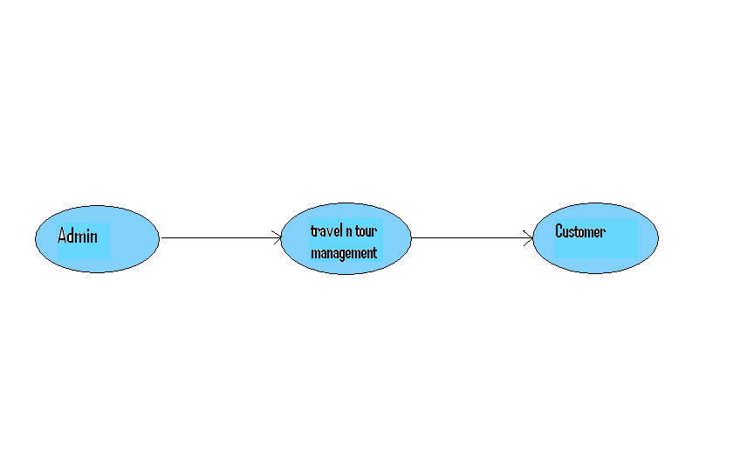

Page 8
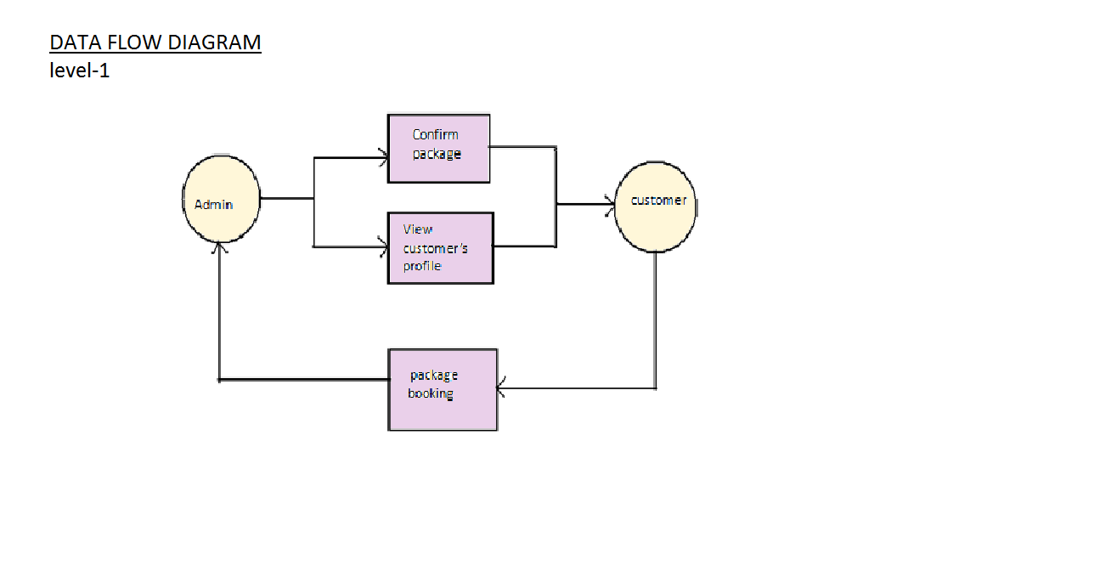

Page 9

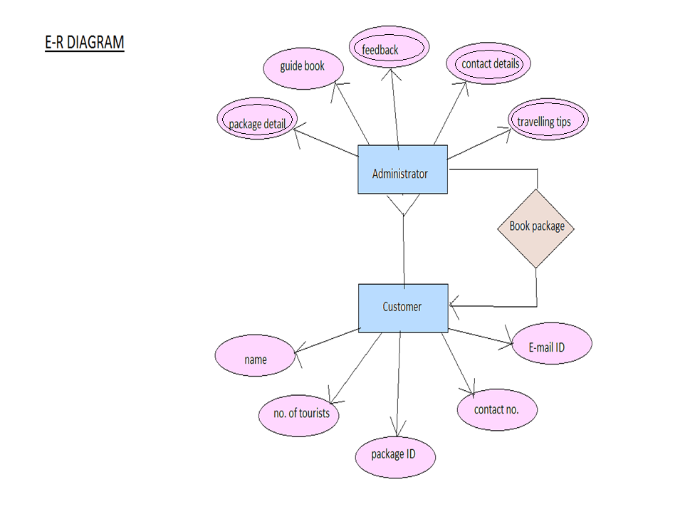

Page 10
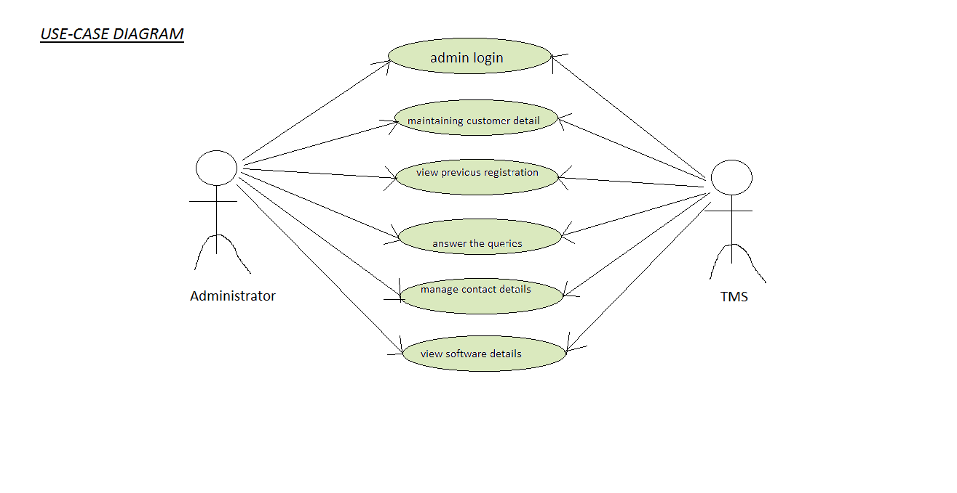

Page 11

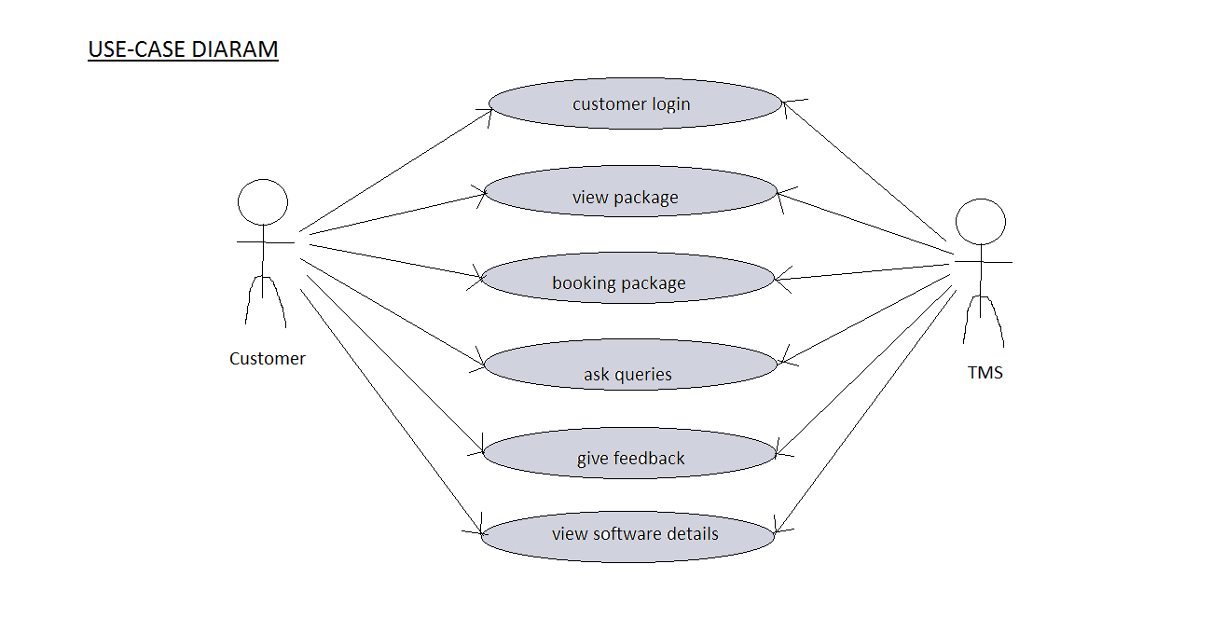

Page 12
Advantages of the Product

- No hardware purchase or maintenance is needed.
- Easy access
- Can be easily provided worldwide.
- Improved efficiency, reduce costs.
- Software will be designed in that way that it will provide rich
user experience, so that the users would get attracted
towards it.
- Automated process of requesting and approving travel.
- Speedy access
- Software will Satisfy travelers & employees with
its superior service.

Page 13

RISKS

- Our software is not platform independent.
- Product should be developed within deadline

Page 14
Result

Administrator can log in via facility of administrator login required a password. His name will be asked by the program. After login he can view the tour packages, guide book. Travel tips, FAQ, Feedback given by customers, previous booking details, contact information, software details.
Customer can login by same procedure but password is not required. He can view tour packages, guide book, traveling tips, FAQ, Feedback, Contact details and he can register himself for the tour and the package will be booked for him.

Page 15

Conclusion

- The projrct took approx 15 days to complete.
- Project is developed modularly.

Page 16

Source Code-

#include<conio.h>
#include<string.h>
#include<fstream.h>
#include<process.h>
#include<time.h>
class start
{
private:
char name[20];
public:
void password();
void display_current_date_getting_started();
void get_name()
{
clrscr();
char ch[2];
cin.getline(ch,2);
cout<<"Enter your name: ";
cin.getline(name,20);
}
const char* show_name()
{
return name;
}
};
start s;
class tasks
{
protected:
int task,package;
void view_packages();
void FAQ();
void contacts();
void guide_book();
void travel_tips();

Page 17
void login();
};
class tasks_customer:public tasks
{
void booking();
void give_feedback();
public:
void select_task();
};
class tasks_admin:public tasks
{
void view_feedback();
void software_details();
void previous_booking_details();
public:
void select_task();
};
int res=0;
class book_package
{
private:
char name[20],address[50],city[20],state[20],country[20],email[30];
char pincode[7],contact_no[11];
int package_ID,no_of_guests;
public:
void get();
void show();
void res_no();
};
void book_package::get()
{
clrscr();
char ch[2];
cin.getline(ch,2);
cout<<"Name : ";
strcpy(name,s.show_name());
cout<<name<<endl;
cout<<"Address : ";
Page 18
cin.getline(address,50);
cout<<"City : ";
cin.getline(city,20);
cout<<"State : ";
cin.getline(state,20);
cout<<"Country : ";
cin.getline(country,20);
cout<<"Pincode : ";
cin.getline(pincode,7);
cin.getline(ch,2);
cout<<"Contact no : ";
cin.getline(contact_no,11);
cin.getline(ch,2);
cout<<"Email ID : ";
cin.getline(email,30);
again:
cout<<"Package ID : ";
cin>>package_ID;
if(package_ID>4||package_ID<1)
{
cout<<"Wrong input. Enter again"<<endl;
goto again;
}
cout<<"Number of guests : ";
cin>>no_of_guests;
cout<<"Your resistration number is "<<res<<" and you have to pay an ammount of Rs ";
switch(package_ID)
{
case 1:
cout<<(long)20000*no_of_guests;
break;
case 2:
cout<<(long)167000*no_of_guests;
break;
case 3:
cout<<(long)74999*no_of_guests;
break;
case 4:
Page 19
cout<<(long)200000*no_of_guests;
}
cout<<" to \nconfirm your resistration.";
cout<<"\nThanks for using our service.";
}
void book_package::show()
{
cout<<"Name : "<<name<<endl;
cout<<"Address : "<<address<<endl;
cout<<"City : "<<city<<endl;
cout<<"State : "<<state<<endl;
cout<<"Country : "<<country<<endl;
cout<<"Pincode : "<<pincode<<endl;
cout<<"Contact no : "<<contact_no<<endl;
cout<<"Email ID : "<<email<<endl;
cout<<"Package ID : "<<package_ID<<endl;
cout<<"Number of guests : "<<no_of_guests<<endl;
}
void book_package::res_no()
{
fstream fobj("D:\\RES.txt",ios::out|ios::in|ios::binary);
res=fobj.get();
if(fobj.eof())
{
res=1;
fobj.close();
fobj.open("D:\\RES.txt",ios::out|ios::trunc);
fobj.put(res);
}
else
{
res++;
fobj.close();
fobj.open("D:\\RES.txt",ios::out|ios::trunc);
fobj.put(res);
}
fobj.close();
}
class contact_info
Page 20
{
private:
char contact_no[11];
char email_ID[30];
public:
void view_contacts();
void edit_contacts();
};
contact_info ci;
void contact_info::edit_contacts()
{
clrscr();
fstream obj("D:\\Contacts.txt",ios::out|ios::in);
char ch=obj.get();
if(obj.eof())
{
cout<<"no contact information is saved yet.\nAdd now(y/n)\n";
cin>>ch;
if(ch=='n'||ch=='N')
{
obj.close();
}
else
{
cout<<"Phone no : ";
char ch[2];
cin.getline(ch,2);
cin.getline(contact_no,11);
cin.getline(ch,2);
cout<<"Email ID : ";
cin.getline(email_ID,30);
fstream fobj("D:\\Contacts.txt",ios::out|ios::binary);
fobj.write((char*)&ci,sizeof(ci));
fobj.close();
}
}
else
{
fstream obj("D:\\Contacts.txt",ios::out|ios::in);
Page 21
obj.read((char*)&ci,sizeof(ci));
cout<<"Phone no : "<<contact_no;
cout<<"\nEmail ID : "<<email_ID;
cout<<"\nEdit contact information(y/n)\n";
cin>>ch;
if(ch=='n'||ch=='N')
{
obj.close();
}
else
{
cout<<"Phone no : ";
char ch[2];
cin.getline(ch,2);
cin.getline(contact_no,11);
cin.getline(ch,2);
cout<<"Email ID : ";
cin.getline(email_ID,30);
fstream fobj("D:\\Contacts.txt",ios::out|ios::binary|ios::trunc);
fobj.write((char*)&ci,sizeof(ci));
fobj.close();
}
}
}
void contact_info::view_contacts()
{
clrscr();
fstream obj("D:\\Contacts.txt",ios::out|ios::in);
obj.get();
if(obj.eof())
{
cout<<"no contact information is saved yet.\nPress any key to exit.";
}
else
{
obj.seekg(0);
obj.read((char*)&ci,sizeof(ci));
Page 22
cout<<"Phone no : "<<contact_no;
cout<<"\nEmail ID : "<<email_ID;
}
obj.close();
}
book_package info;
tasks t;
tasks_customer tc;
tasks_admin ta;
int l;
void main()
{
clrscr();
gotoxy(10,15);
cout<<"welcome to...";
cout<<"\n\n ***TRAVEL AND TOUR MANAGEMENT SOFTWARE***"<<endl;
getch();
clrscr();
s.password();
getch();
}
void start::display_current_date_getting_started()
{
clrscr();
char date[9];
char time[9];
_strdate(date);
_strtime(time);
cout<<"Today's Date: "<<date<<"Time: "<<time<<endl;
}
void start::password()
{
clrscr();
char arr[]="annptms";
cout<<"1. Administrator login";
cout<<"\n2. Customer login";
cout<<"\nenter login serial";
int a;
Page 23
cin>>a;
if(a==1)
{
l=1;
int attempts=1;
do
{
clrscr();
char arr2[7];
cout<<"Enter password : ";
for(int i=0;i<=6;i++)
{
arr2[i]=getch();
cout<<"*";
}
getch();
for(i=0;i<7;i++)
{
if(arr[i]!=arr2[i])
{
break;
}
}
if(i==7)
{
break;
}
else
{
attempts++;
cout<<"\nPassword incorrect, re enter the password";
getch();
}
}while(attempts<=3);
if(attempts>3)
{
clrscr();
cout<<"Sorry, you can't be logged in as admin";
Page 24
cout<<"\nThank you for using this software. Press any key to exit";
getch();
exit(0);
}
s.get_name();
s.display_current_date_getting_started();
ta.select_task();
}
if(a==2)
{
l=2;
s.get_name();
s.display_current_date_getting_started();
tc.select_task();
}
else
{
cout<<"Wrong entry, enter again";
s.password();
}
}
void tasks_customer::select_task()
{
cout<<"\nHello "<<s.show_name()<<endl;
cout<<"You are using..."<<endl;
cout<<"\n ***TRAVEL AND TOUR MANAGEMENT SOFTWARE***"<<endl;
cout<<" ****************************";
cout<<"\n\nPlease select any task to do..."<<endl;
cout<<"1. View our packages"<<endl;
cout<<"2. Guide Book"<<endl;
cout<<"3. Book your trip"<<endl;
cout<<"4. Traveling tips"<<endl;
cout<<"5. FAQ"<<endl;
cout<<"6. Give Feedback"<<endl;
cout<<"7. Contacts"<<endl;
cout<<"8. Login with another user"<<endl;
cout<<"9. Exit from the program"<<endl;
Page 25
cout<<"Enter your task serial: ";
cin>>task;
switch(task)
{
case 1:
view_packages();
break;
case 2:
guide_book();
break;
case 3:
booking();
break;
case 4:
travel_tips();
break;
case 5:
FAQ();
break;
case 6:
give_feedback();
break;
case 7:
contacts();
break;
case 8:
login();
break;
case 9:
{
clrscr();
cout<<"Thank You for trying this software !!!\n\tThis is the end of program....\nPress any key to exit....";
getch();
exit(0);
}
default:
{
clrscr();
Page 26
cout<<"Invalid task serial.\nPress any key to continue....";
getch();
s.display_current_date_getting_started();
tc.select_task();
}
}
}
void tasks_admin::select_task()
{

cout<<"\nHello "<<s.show_name()<<endl;
cout<<"You are using..."<<endl;
cout<<"\n ***TRAVEL AND TOUR MANAGEMENT SOFTWARE***"<<endl;
cout<<" ****************************";
cout<<"\n\nPlease select any task to do..."<<endl;
cout<<"1. View packages"<<endl;
cout<<"2. Guide Book"<<endl;
cout<<"3. Traveling tips"<<endl;
cout<<"4. FAQ"<<endl;
cout<<"5. View Feedback"<<endl;
cout<<"6. View previous booking details"<<endl;
cout<<"7. Contacts"<<endl;
cout<<"8. View Software deatils"<<endl;
cout<<"9. Login with another user"<<endl;
cout<<"10. Exit from the program"<<endl;
cout<<"Enter your task serial: ";
cin>>task;
switch(task)
{
case 1:
view_packages();
break;
case 2:
guide_book();
break;
case 3:
travel_tips();
Page 27
break;
case 4:
FAQ();
break;
case 5:
view_feedback();
break;
case 6:
previous_booking_details();
break;
case 7:
contacts();
break;
case 8:
software_details();
break;
case 9:
login();
break;
case 10:
{
clrscr();
cout<<"Thank You for trying this software !!!\n\tThis is the end of program....\nPress any key to exit....";
getch();
exit(0);
}
default:
{
clrscr();
cout<<"Invalid task serial.\nPress any key to continue....";
getch();
s.display_current_date_getting_started();
ta.select_task();
}
}
}
void tasks::view_packages()
Page 28
{

clrscr();
cout<<"\n Enjoy your holidays at...";
cout<<"\n\n 1. Beauty of Himalayas and Taj Mahal\n 2. South African Delight\n 3. Gorgeous Maldives\n 4. Classic Italy";
cout<<"\n\nEnter serial number of package: ";
cin>>package;
switch(package)
{
case 1:
{
clrscr();
gotoxy(20,4);
cout<<"Beauty of Himalayas and Taj Mahal";
cout<<"\n *****************************";
cout<<"\n\n Catagory : *****";
cout<<"\n Duration : 10 Days/9 Nights";
cout<<"\n Route : >Delhi>Srinagar>Delhi>Agra>Jaipur>Delhi";
cout<<"\n Validity : From 1st May 2011to 30th June 2011";
cout<<"\n Departure : Every Tuesday form Delhi";
cout<<"\n Total expences including reservation, travel and\n accomodation: Rs 20,000 per head";
cout<<"\n Package ID : 001";
getch();
break;
}
case 2:
{
clrscr();
gotoxy(28,4);
cout<<"South African Delight";
cout<<"\n *****************";
cout<<"\n\n Catagory : *****";
cout<<"\n Duration : 10 Nights & 11 Days";

Page 29
cout<<"\n Oudtshoorn | 1 Night\n\t\t Knysna | 3 Night\n\t\t Cape Town | 2 Night\n\t\t Kruger National Park | 2 Night\n\t\t Sun City | 1 Night Johannesburg";
cout<<"\n Validity : From 10th May 2011 to 22th August 2011";
cout<<"\n Departure : From Mumbai or delhi";
cout<<"\n Total expences including reservation, flight and\n accomodation: Rs 1,67,000 per head";
cout<<"\n Package ID : 002";
getch();
break;
}
case 3:
{
clrscr();
gotoxy(30,4);
cout<<"Gorgeous Maldives";
cout<<"\n *************";
cout<<"\n\n Catagory : *****";
cout<<"\n Duration : 3 Nights & 4 Days";
cout<<"\n Hotel : Taj Exotic Resort & Spa";
cout<<"\n Validity : 10th May 2011 to 22nd August 2011";
cout<<"\n Departure : From New Delhi, Mumbai, Banglore, Chennai.";
cout<<"\n Total expences including reservation, flight and\n accomodation: Rs 74,999 per head";
cout<<"\n Package ID : 003";
getch();
break;
}
case 4:
{
clrscr();
gotoxy(32,4);
cout<<"Classic Italy";
cout<<"\n *********";
cout<<"\n\n Catagory : *****\n Duration : 12 Days and 11 Nights";
Page 30
cout<<"\n Tour Details:";
cout<<"\n Day 1: Rome";
cout<<"\n Day 2: Rome – Assisi – Siena – Florence";
cout<<"\n Day 3: Florence";
cout<<"\n Day 4: Florence – Bologna – Padova – Venice";
cout<<"\n Day 5: Venice";
cout<<"\n Day 6: Venice – Montepulciano – Rome";
cout<<"\n Day 7: Rome";
cout<<"\n Day 8: Rome – Naples – Pompei – Sorrento";
cout<<"\n Day 9: Sorrento";
cout<<"\n Day 10: Sorrento – Capri";
cout<<"\n Day 11: Capri – Rome";
cout<<"\n Day 12: Rome";
cout<<"\n Validity : 15th May 2011 to 1st September 2011";
cout<<"\n Departure : From New Delhi, Mumbai";
cout<<"\n Total expences including reservation, flight and\n accomodation: Rs 2,00,000 per head";
cout<<"\n Package ID : 004";
getch();
break;
}
default:
{
clrscr();
cout<<"Invalid package serial.\nPress any key to continue....";
getch();
}
}
s.display_current_date_getting_started();
if(l==2)
{
tc.select_task();
}
else
{
Page 31
ta.select_task();
}
}
void tasks::FAQ()
{
clrscr();
cout<<"\n\t\t\t\tFAQ";
cout<<"\n\t\t\t *****\n\n";
fstream obj;
obj.open("D:\\FAQ.txt",ios::out|ios::in|ios::app);
obj.seekg(0);
char c;
c=obj.get();
while(obj.eof()==0)
{
cout<<c;
c=obj.get();
}
if(l==2)
{
cout<<"Ask a question(y/n)\n";
cin>>c;
if(c=='y'||c=='Y')
{
int i=0;
cout<<"Enter your question here\n";
cout<<"Q ";
obj<<"Q ";
char str[100];
char ch[2];
cin.getline(ch,2);
cin.getline(str,100);
while(str[i]!='\0')
{
c=str[i];
obj.put(c);
i++;
}
obj<<endl;
Page 32
char arr[20];
strcpy(arr,s.show_name());
for(int j=0;arr[j]!='\0';j++)
{
obj.put(arr[j]);
}
obj<<endl<<endl;
}
}
if(l==1)
{
cout<<"Answer a question(y/n)\n";
cin>>c;
if(c=='y'||c=='Y')
{
int i=0;
cout<<"Enter the answer here\n";
cout<<"A ";
obj<<"A ";
char str[100];
char ch[2];
cin.getline(ch,2);
cin.getline(str,100);
while(str[i]!='\0')
{
c=str[i];
obj.put(c);
i++;
}
obj<<endl;
char arr[20];
strcpy(arr,s.show_name());
for(int j=0;arr[j]!='\0';j++)
{
obj.put(arr[j]);
}
obj<<endl<<endl;
}
}
Page 33
obj.close();
getch();
s.display_current_date_getting_started();
if(l==2)
{
tc.select_task();
}
else
{
ta.select_task();
}
}
void tasks::guide_book()
{
clrscr();
cout<<"BEAUTY OF HIMALAYAS AND TAJ MAHAL:";
cout<<"\n\n\tIndia is a medley of fascinating colors & culture, an historical legency, a canvas of architectural masterpieces, & an extravagant exuberance of royal splendour and home to the eternal symbol of love- the Taj Mahal. Taj Mahal is the finest example of Mughal architecture, a style that combines elements from Persian, Islamic and Indian architectural styles and stands at no. 1 position among 7 wonders of world. There is also Himalayas, the mountain range in Asia, separating the Indian subcontinent from the Tibetan Plateau. Its the home of all 14 of the world's highest peaks, including Mount Everest. There are many dazzling hill stations located at these mountain ranges which gives snoothing environment to the tourists.";
cout<<"\n\n\nSOUTH AFRICAN DELIDHT:";
cout<<"\n\n\tAfrica is the world's second-largest and second most-populous continent, after Asia. South Africa has an abundance of natural beauty. Its breathtaking scenery, prolific wildlife and the diversity of our vibrant cultures and people are there for everyone to see and enjoy.";
cout<<"\n\n\nGORGEOUS MALDIVES:";
cout<<"\n\n\tThe Maldives are an archipelago of 1,190 coral islands grouped into 26 coral atolls (200 inhabited islands, plus 80 islands with tourist resorts) in the Indian Ocean.Maldives is very famous for its natural beauty which includes the blue ocean and white beaches, accompanied by clean air and pleasant temperatures. The climate of the Maldives is ideal for visitors to get engaged in water sports such as swimming, fishing, scuba diving, snorkeling, water-skiing and windsurfing.Due to its extraordinary underwater scenery and
Page 34
clean water, Maldives is ranked among the best recreational diving destinations of the world.";
cout<<"\n\n\nCLASSIC ITALY:";
cout<<"\n\n\tWith more than 43.2 million tourists a year, Italy is the fourth highest tourist earner,[1] and fifth most visited country in the world,taly is an especially popular tourist destination in Europe, as well as in the rest of the world. The history and geography of the country can explain why it can be a tourist must-see. The Roman Empire, Middle Ages, and Renaissance all helped give rise to the many cultural phenomena that attract visitors year-round. Tourists flock to Italy to see sites, such as the Colusseum in Rome, the Statue of David in Florence and the ruins of Pompeii. Rome, the capital city, is also the host to the Vatican, the mecca of Roman Catholicism.Italy has some of the world's most ancient tourist resorts, dating back to the time of the Roman Republic, when destinations such as Pompeii, Naples Ischia, Capri and especially Baiae were popular with the rich of Roman society.";
getch();
s.display_current_date_getting_started();
if(l==2)
{
tc.select_task();
}
else
{
ta.select_task();
}
}
void tasks::travel_tips()
{
clrscr();
gotoxy(30,4);
cout<<"TRAVELING TIPS\n";
cout<<" **********\n";
cout<<"\n* Be Aware of What Not to Bring in Checked Baggage on Airlines and Airline Carry On Baggage.";
cout<<"\n\n* Pack Smart & Spend Less Time in Airport Security Lines";
cout<<"\n\n* Prefer green travel, Use environmentally responsible services";
cout<<"\n\n* Look for all inclusive packages, such as resorts and
Page 36
travel";
cout<<"\n\n* Ask your travel agent about locations that may be less costly as they are in their 'off season'.";
cout<<"\n\n* Buy travel insurance, it may cost more upfront, but has the potential to save you thousands.";
cout<<"\n\n* Arrive early. Difficult airport parking, long lines at security checkpoints and the possibility of the airline overselling the flight and bumping passengers, should all be considered when deciding what time to arrive at the airport. Give yourself plenty of extra time.";
cout<<"\n\n* Prefer using a Travel Agent. Strong working relationships with travel suppliers and the latest in computer reservations technology enable travel agents to access the most up-to-date information on how to get you the best value.";
cout<<"\n\n* Taking the necessary steps to make sure you and your family have a safe and healthy trip.";
cout<<"\n\n* Always have your travel agent's contact information with you. It's good to have an ally back home you can call whenever a problem arises.";
getch();
s.display_current_date_getting_started();
if(l==2)
{
tc.select_task();
}
else
{
ta.select_task();
}
}
void tasks::contacts()
{
if(l==1)
{
ci.edit_contacts();
}
else
{
ci.view_contacts();
}
Page 37
getch();
s.display_current_date_getting_started();
if(l==2)
{
tc.select_task();
}
else
{
ta.select_task();
}
}
void tasks::login()
{
char a[2];
cin.getline(a,2);
s.password();
}
void tasks_customer::booking()
{
fstream fobj("D:\\Booking.txt",ios::in|ios::out|ios::binary|ios::app);
info.res_no();
info.get();
fobj.write((char*)&info,sizeof(info));
fobj.close();
getch();
s.display_current_date_getting_started();
tc.select_task();
}
void tasks_customer::give_feedback()
{
clrscr();
cout<<"\n\t\t\t\tFEEDBACK";
cout<<"\n\t\t\t **********\n\n";
fstream obj;
obj.open("D:\\Feedback.txt",ios::out|ios::in|ios::app);
obj.seekg(0);
char c;
c=obj.get();
while(obj.eof()==0)
Page 38
{
cout<<c;
c=obj.get();
}
cout<<"Submit your feedback(y/n)\n";
cin>>c;
if(c=='y'||c=='Y')
{
int i=0;
cout<<"Enter your feedback here\n";
cout<<"=> ";
obj<<"=> ";
char str[100];
char ch[2];
cin.getline(ch,2);
cin.getline(str,100);
while(str[i]!='\0')
{
c=str[i];
obj.put(c);
i++;
}
obj<<endl;
char arr[20];
strcpy(arr,s.show_name());
for(int j=0;arr[j]!='\0';j++)
{
obj.put(arr[j]);
}
obj<<endl<<endl;
}
obj.close();
getch();
s.display_current_date_getting_started();
tc.select_task();
}
void tasks_admin::view_feedback()
{
clrscr();
Page 39
cout<<"\n\t\t\t\tFEEDBACK";
cout<<"\n\t\t\t **********\n\n";
fstream obj;
obj.open("D:\\Feedback.txt",ios::out|ios::in|ios::app);
obj.seekg(0);
char c;
c=obj.get();
while(obj.eof()==0)
{
cout<<c;
c=obj.get();
}
obj.close();
getch();
s.display_current_date_getting_started();
ta.select_task();
}
void tasks_admin::software_details()
{
clrscr();
gotoxy(20,5);
cout<<"***Software Specification***"<<endl;
cout<<"\nPrograming language : C++"<<endl;
cout<<"Aim : Developing a software which can be in Travel Agencies providing better user experience."<<endl;
cout<<"Hope you like it...\nThank You for using this program\nPress any key to return to the main task menu......";
getch();
clrscr();
s.display_current_date_getting_started();
ta.select_task();
}
void tasks_admin::previous_booking_details()
{
int count;
ifstream obj("D:\\RES.txt",ios::in);
res=obj.get();
obj.close();
ifstream fobj("D:\\Booking.txt",ios::in|ios::out|ios::binary);
Page 40
clrscr();
if(res==-1)
{
cout<<"No one is resistered till now";
getch();
s.display_current_date_getting_started();
ta.select_task();
}
else
{
again:
cout<<"Enter resistration no : ";
cin>>res;
fobj.seekg(0,ios::end);
count=fobj.tellg()/sizeof(info);
if(count>=res&&res>0)
{
fobj.seekg((res-1)*sizeof(info),ios::beg);
fobj.read((char*)&info,sizeof(info));
info.show();
fobj.close();
getch();
s.display_current_date_getting_started();
ta.select_task();
}
else
{
cout<<"Invalid resistration number"<<endl<<"Enter again";
getch();
clrscr();
goto again;
}
fobj.close();
}
}

Page 41

Biblography

- Book - E BALAGURUSAMY, c++
- Sites – www.wikipedia.org
www.google.com
www.cpeograming.com

Page 42

